**Vision:**

**Introduction**

We envision that the Fitbit will be a wearable accessory that gives users real time data on their daily activity, from tracking their physical activities to keeping a log of their sleeping habits. Using this data, the fitbit will help the user improve their daily lives.

**Positioning**

***Business Opportunity***

Current health monitor systems are often overpriced and difficult for users to learn how to use. Users are often faced with the challenge of deciding between more functionality (that often goes unused) in exchange for a larger display and higher market value, or a smaller, lower-contrast display that has less functionality.

***Problem Statement***

Many health monitor systems will only allow the user to use their technology and applications. Users have little to no say on what their system is capable of, and are only able to focus on the price tag. A user should not have to focus so much on the screen size and color of the watch band in order to have their system do what it is intended to do. Health monitor systems should be simple and easy to use with a price that won’t break the user’s bank.

***Product Position Statement***

Our health monitor system is for the active user who wants an everyday watch that can track their daily habits without breaking the bank. Our system will include step tracking, daily calories burned, distance travelled, and a nightly sleep analysis all on the user’s wrist. This system will be available at a low price-point for the user and will help them to improve their daily lives by setting goals and viewing their habits.

***Alternatives and Competition***

Brands like Fitbit already dominate the market, but at such a high price point that many people cannot afford to invest in one. There are many similar products available for strikingly low costs, but that have little functionality and often stop working very quickly, thus needing to be replaced often.

**Stakeholders and Descriptions**

***Market Demographics***

Our market demographic is anyone of any age who wants to keep track of a specific habit that our system has to offer. Age, gender, race, education, and knowledge of the system do not matter. Our system will be easy to learn and maintain a high usability and memorability throughout the lifecycle of the device.

***Stakeholder (Non-User) Summary***

Investors in our product will likely want to see improvements on the system over time, as well as an increase in sales.

Us as a company are stakeholders, as we will use the funds generated from the device in order to make new and improved products in the future, as well as use certain generated user statistics to give us an understanding of what features our users utilize most frequently, and what can be improved upon.

***User Summary***

Our users will expect for the system to perform the functions we have guaranteed with purchase. These features include step counting, calories burned, distance travelled, and sleeping habits. The use of these features will help users to monitor and improve their habits.

***Key High-Level Goals and Problems of the Stakeholders***

Goals: To generate more revenue as well as increase interest in the system in order to increase sales.

Problems: The rivalry of the market could cause a problem in sales, as many other health monitor systems exist and already have stakes on the market.

***User-Level Goals***

User: check time, view step count, view current heart rate, view distance travelled, view sleep habits

System: calculate variables, such as steps, calories, distance, etc. Use gyroscope, pedometer, and pulse monitor.

***User Environment***

The system can be used in any user-environment. Activity-level of the user does not determine the likeliness of the user to utilize the system.

**Product Overview**

***Product Perspective***

The product will be used in all environments, thus can reside anywhere.

***Summary of Benefits***

Will give users an easy way to view certain daily habits and allow them a way to monitor those habits so that they may improve on them over time.

***Assumptions and Dependencies***

It is assumed that the user will wear the device at all times. Measurement of heart rate, steps, etc., will not be accurate if the device is not properly placed on the user.

***Cost and Pricing***

We aim for each unit to cost no more than $60 depending on functionality. This is at least half the price of the cheapest Fitbit system.

**Summary of System Features**

* Pedometer used to calculate and update steps taken by the user
* Gyroscope
* Pulse Monitor used to calculate the user’s current heart rate
* The combination of steps taken and heart rate will allow the system to calculate calories burned
* A basic watch interface that allows the user to view the current time and date

**Other Requirements and Constraints**

* The user must have the device fastened to their wrist in order to be used accurately for anything besides time and date reading
* Watch may only accommodate users with up to a certain circumference of wrist

**Risk List:**

1. User Risks:
   1. Data about the user’s activity is stolen either directly from the device or in transit between the fitbit and an external device (computer, phone).
   2. Battery malfunction causing burn damage to user.
   3. Prolonged wear causing skin irritation to the user’s wrist.
2. Team Risks:
   1. Conflicting schedules between teammates.
   2. Differing levels of Java coding experience.

**Supplemental Specifications:**

**Introduction**

This document is the repository of Fitbit requirements not captured in the use cases.

**Functionality**

The current time is being accurately tracked by the fitbit. Events being tracked by the fitbit have an accurate timestamp of when they occurred.

**Usability**

The display will show limited amounts of information so it is readable to the user. Text should be high contrast. User can move through visual interfaces to see different information.

**Reliability**

*Recoverability*

If there is a failure in the hardware during usage, such as the device’s battery dying, the user’s data thus far will still be recorded in the Fitbit’s software. The user will still be able to access their logged data.

The Fitbit is water resistant, therefore users should not have to worry about the watch malfunctioning due to water damage in most situations.

**Performance**

The hardware must be able to update its logs and data on the user’s activities in real-time.

**Supportability**

*Configurable*

Based on the model. Some models with larger screens will allow the user to display more information to the user at one time. The user will have the ability to select what they want to display.

**Implementation Constraints**

*Hardware constraint*

The software must be able to run on the smaller hardware contained in the fitbit.

**Interfaces**

*Noteworthy Hardware and Interfaces*

* Fitbit screen face (used for displaying time, date, heart rate, calories burned, widgets installed by the user, etc.). This face should have touch capabilities that allow the user to cycle through the different functionalities of the Fitbit.
* PurePulse (used to track the user’s heart rate. This technology allows for an easier way for the user to track their heart rate without the use of bulkier and heavier technology).
* SmartTrack (used to track the various activity a user is performing. This activity could include walking, running, biking, swimming, aerobic workout, elliptical workout, and various sports).
* Sleep Tracking (used to measure the user’s time awake as well as asleep. Variables measured while asleep include REM cycles and the various stages of the sleep cycle).

*Software*

* Javascript
* CSS
* SVG

**Glossary:**

* BPM - beats per minute; terminology used when calculating current heart rate
* MPH - miles per hour; terminology used when calculating speed of user and distance travelled
* Calories - measurement of energy in food; terminology used when calculating the amount of calories burned by the user in a given day.
* REM sleep- stage of sleep where rapid eye movement occurs. Terminology used when calculating the sleep activity of a user on a given night.
* Pedometer- device within the system that tracks the number of steps the user has taken
* Pulse monitor- device within the system that tracks the user’s current pulse and gives an updated heart rate

**Use Case 1:** Track an Activity

**Level:** User Goal

**Primary Actor:** Fitbit User

**Stakeholders and Interests:** Fitbit User - Wants to be able to view their activity information for the current day. Activity information includes, number of steps, distance, minutes active, minutes stationary.  **Preconditions:** The fitbit has been setup for the specific user, and the user is correctly wearing the device.

**Postconditions:** The activity information is displayed to the user on the fitbit.

**Main Success Scenario:**

1)The user puts on his/her fitbit and powers it on.

2)The user performs an activity such as running.

3) During the activity the fitbit monitors and displays heart rate(Use Case 1A), calories burned(Use Case 1B), and steps walked(Use Case 1C).

4) The user after completing the physical activity clicks on the fitbit to view the average heart rate, calories burned and steps walked from the activity.

**Extensions:**

* View Extensions for UC1A, UC1B, UC1C.

**Technology and Data Variations:**

* The Distance displayed in the United States, Liberia, Myanmar should be in Imperial Units. Everywhere else distance should reflected using the Metric system.
* The user may manually enter the activity and duration of the activity if they were not wearing the fitbit (i.e., if the user was on a treadmill running for 30 minutes). This will automatically calculate the amount of calories burned (UC1B).

**Special Requirements:**

* Language internationalization on the text displayed.
* Clear UI that displays the user’s activity information

**Frequency:** Continuous

**Use Case 1A:** Monitor Heart Rate

**Level:** User Sub-Goal

**Primary Actor:** Fitbit Device

**Stakeholders and Interests:** Fitbit Device: Wants to keep track of user’s heart rate during times of activity and no activity. **Preconditions:** The fitbit is set up specifically for the user and is worn during the user’s desired times for tracking heart rate. The clock must be worn so the pulse monitor is against the user’s pulsepoint. The user is wearing the device and has powered it on.

**Postconditions:** The Fitbit UI will display the user’s current heart rate on the display. The fitbit has gathered data on the user’s heart rate.

**Main Success Scenario:**

1) The user continuously wears the clock during the time they want to track their heart rate.

2) The fitbit device is continually taking in heart rate information from the user’s pulse with a heart rate sensor

3) The Fitbit will constantly gather and display the user’s current heart rate, giving immediate feedback to the user.

**Extensions:**

1. At any time, the fitbit shuts down due to power loss.
   1. The user’s data will not be lost due to power loss.
   2. The user must charge the Fitbit to allow the device to power back on.
   3. The user must put the Fitbit back on their wrist with the pulse monitor adjusted to align over their pulse point before the Fitbit will continue monitoring their heartbeat.
2. The Fitbit user is not wearing the Fitbit.
   1. The Fitbit will not track anything (This includes heart rate, steps taken, activities engaged in, etc.) and can only be used for timekeeping purposes (see UC3).
   2. The user must put the Fitbit on before it will continue tracking their heart rate.
3. The Fitbit user is wearing the Fitbit, but does not have the pulse monitor aligned with the pulse point in their wrist.
   1. The Fitbit will not be able to detect their pulse and therefore will not be able to keep track of the user’s constant heart rate.
   2. The user will need to adjust the clock so the pulse monitor is aligned with their pulse point.
   3. The Fitbit will then continue to keep a constant track of the user’s heart rate.
4. The user’s heart rate becomes too high and is now a health risk.
   1. The Fitbit will vibrate to alert the user of a notification.
   2. An on screen prompt will tell the user that their heart rate is too high.
      1. If the user is doing a physical activity, they should slow down to lessen their heart rate before continuing.
      2. If the user is stationary, therefore not doing anything strenuous to cause their heart rate to become too high, they should seek out medical attention immediately.
   3. Once the user’s heart rate has returned to a healthy range, they will be able to continue tracking their heart rate as normal.
5. The user’s heart rate becomes too low and is now a health risk.
   1. If the user is asleep and their heart rate is low because of that, the Fitbit will not notify them.
   2. If the user is awake, the Fitbit will vibrate to alert the user of a notification.
      1. An on screen prompt will tell the user that their heart rate is too low.
         1. If the user is stationary or in a relaxed state and does not feel the need to seek medical attention, then they do not have to.
         2. If the user is stationary, in a relaxed state, or in an active state and feels that it is necessary, they should seek out medical attention.
      2. Once the user’s heart rate has returned to a healthy range, they will be able to continue tracking their heart rate as normal.

**Special Requirements:**

* Clear UI that can be easily read by the user so that they can accurately read their constant heart rate at any given time.
* Backlit screen so the user’s on screen information can be read at any time.
* Sensitive sensors that can accurately monitor the user’s pulse on their wrist.

**Frequency:** Constant

**Use Case 1B:** Monitor Calories Burned

**Level:** User Sub-Goal

**Primary Actor:** Fitbit Device

**Stakeholders and Interests:** Fitbit User, Fitbit Device **Preconditions:** The user has correctly set up for the user with accurate information. The fitbit device is powered on and is being worn by the fitbit user.

**Postconditions:** The fitbit UI will display the calories burned. The fitbit device has gathered data on the calories burned by the user.

**Main Success Scenario:**

1) The user continuously wears the clock during the time the device is tracking the calories burned.

2) The fitbit will calculate the calories burned based off of the user’s activity, the duration of the activity, and the user’s weight.

3) The fitbit will constantly update the calories burned whether the user is walking or doing intense activity.

4) The fitbit will display the calories burned so far for the day to the user on the UI display.

**Extensions:**

1. At any time, the fitbit shuts down due to power loss.
   1. The user’s data will not be lost due to power loss.
   2. The user must charge the Fitbit to allow the device to power back on.
   3. The user must put the Fitbit back on their wrist before the fitbit will begin monitoring Calories burned
2. The user was not wearing the fitbit during an activity.
   1. The user will be able to manually enter the activity and duration of the activity (if they know that information) and the amount of calories burned will automatically be calculated.
3. The fitbit device resets the calories burned data at the default or user specified time every 24 hours.
4. The user updates their weight.
   1. The total amount of calories burned for the day will be recalculated to display a more accurate reading based off of the user’s new weight.
   2. The calories burned will continue updating throughout the day with the new weight included in the calculations, and will continue using this calculation until the user updates their weight again.

**Technology and Data Variations:**

* The user could manually enter calories burned if they were not wearing the fitbit during their activity if they are able to get the information from another source (i.e. a treadmill).

**Special Requirements:**

* The user’s weight must be up-to-date for an accurate calculation.

**Frequency:** Continuous

**Use Case 1C:** Monitor Steps Walked

**Level:** User Sub-Goal

**Primary Actor:** Fitbit Device

**Stakeholders and Interests:** Fitbit User, Fitbit Device **Preconditions:** The user has correctly set up for the user with accurate information.

**Postconditions:** The fitbit UI will display the calories burned. The fitbit device contains data on the steps walked by the user.

**Main Success Scenario:**

1) The user continuously wears the clock during the time the device is tracking the calories steps walked.

2) The fitbit device is continually taking in accelerometer data to calculate the current number of steps walked.

3) The Fitbit will constantly gather and display the user’s steps walked, giving immediate feedback to the user.

**Extensions:**

1. At any time, the fitbit shuts down due to power loss.
   1. The user’s data will not be lost due to power loss.
   2. The user must charge the Fitbit to allow the device to power back on.
   3. The user must put the Fitbit back on their wrist before the Fitbit will continue monitoring their steps walked.
2. The user enters a moving vehicle
   1. The fitbit should recognize that while the user is accelerating steps aren’t being taken, and should not log additional steps
3. The fitbit device resets the calories burned data at the default or user specified time every 24 hours.

**Technology and Data Variations:**

1. User could manually enter their steps taken based on another device (such as their smartphone or steps counted on a treadmill) if they were not wearing their Fitbit.

**Special Requirements:**

**Frequency:** Continuous.

**Use Case 2:** Display Clock

**Level:** User Goal

**Primary Actor:** Fitbit User

**Stakeholders and Interests:**

Fitbit User: Wants to know the current time and date for various reasons

Fitbit Device: wants to know the current time and date for timestamping activities/events **Preconditions:** The user has set up the fitbit and has correctly set the time, date and their timezone.

**Postconditions:** The current time and date are displayed on the fitbit device. Time and date includes the hour, minutes, seconds, day, month, and year.

**Main Success Scenario:**

1. The user has their fitbit powered on.
2. The user navigates to the “Clock” menu.
3. The user can see the current date(day, month, year) and time(hour,minutes,seconds).

**Extensions:**

1. The user has switched time zones.
   1. The user must manually enter in the correct time
   2. Or the user plugs the fitbit into a computer and the correct time is synced
2. The device runs out of battery or is powered off
   1. The device goes into a low power mode where the current time is still being kept
3. The user is not wearing the device
   1. The user can still use the device for timekeeping purposes
4. The user wants to use the clock as a stopwatch
   1. The user clicks the stopwatch button
   2. A stopwatch starting at 00(h):00(m):00(s) is displayed
   3. The clock runs up until the user clicks the stop button or the display reaches 99(h):99(m):99(s)
5. The user wishes to change their clock from standard time to military time, or vice versa.
   1. The user will go into their fitbit’s settings
   2. The user will then select the type of time they want to use.
   3. The watch will automatically convert the time to the appropriate time setting, and will continue operating as normal. The time display will remain under this setting until the user changes it.
6. The user wishes to change their date display information to by day/month/year to month/day/year, or vice versa
   1. The user will go into their fitbit’s settings
   2. The user will then select their date display preferences
   3. The date on the interface will update to the new date display preference and will remain in this format unless the user changes the settings again.

**Technology and Data Variations:**

* The date and time data displayed on the clock screen will differ from timezone to timezone.
* The user can select whether the time is displayed in Standard time or Military time.
* The user can select whether to display the date in day/month/year format (as is used in the USA) or month/day/year format (as is used in the UK)

**Special Requirements:**

* The data displayed is updated real time, and is displayed in a readable manner for the user
* A backlit display so the user can read the time in any lighting, from being in the sun to being in total darkness.

**Frequency:** Continuous

**Use Case 3:** Track Sleep Data

**Level:** User Goal

**Primary Actor:** Fitbit User

**Stakeholders and Interests:**

Fitbit User: Wants to be able to keep a recorded log of their sleeping habits, including their time asleep and their time spent during each stage of the sleep cycle.

Fitbit (Company): Wants users to track their sleeping habits so they can collect valuable data on their user’s activities. **Preconditions:** The Fitbit has been set up specifically for the user and is worn while the user is sleeping.

**Postconditions:** The Fitbit will return a log of the user’s sleep from the time they were asleep.

**Main Success Scenario:**

1) The user puts on his/her Fitbit and powers it on.

2) The user falls asleep while wearing the Fitbit and is asleep for a minimum of one (1) hour.

3) During sleep, the Fitbit will record the user’s specific sleep cycle and duration of sleep. This includes time spent asleep, time spent in the REM stage of sleep, time spent in the other stages of sleep,

4) The user will be able to view their personal sleep data after they wake up. The user will be able to keep track of their overall sleeping habits over various days, and will be able to view trends in their sleep cycles compared to other Fitbit users.

**Extensions:**

1. At any time, the Fitbit shuts down due to power loss.
   1. The user’s sleep data already recorded will not be lost, and is recoverable.
   2. The Fitbit will not continue to track sleep until the Fitbit is charged and attached to the user’s wrist again.
2. The user falls asleep using their fitbit, but is only asleep for less than one (1) hour.
   1. The fitbit will not track this sleep data.
   2. The user must fall asleep and stay asleep for a minimum of one (1) hour for the fitbit to begin tracking their sleep data.
   3. Colors on the UI that are not too harsh on the eyes, as many users who actively track their sleeping habits may view this information right after waking.
3. The user is not wearing their fitbit while sleeping, but still wants the sleep information to be logged onto their device
   1. The user can manually enter the hours they were asleep
   2. This will not be able to tell them useful information about their sleep cycle (i.e. REM sleep and time awake), but will still be able to show them trends in the total amount of time they are sleeping on average per night.

**Technology and Data Variations:**

* The user may manually enter their hours of sleep if they were not wearing the fitbit while they were sleeping. This will clearly not allow the user to view all of the details of their sleep (time in the REM cycle, time awake, etc.) but could still be useful in showing them their total hours of sleep per week. This would also allow the user to enter times asleep that lasted for less than one hour.

**Special Requirements:**

* Clear UI that displays the user’s sleep information
* Colors on the UI that contrast well together so the user is able to easily view and identify their personalized charts that display their sleeping habits
* Backlit screen so the user can read the information in the dark.

**Frequency:** Every time the user wears their Fitbit while sleeping for a minimum of one (1) hour; Daily.

**Use Case 4:** Setup Device

**Level:** User Goal

**Primary Actor:** Fitbit User

**Stakeholders and Interests:**

Fitbit User: Wants to be able to set up the device with their personal specifications (weight, age, gender, etc.)

Fitbit (Company): Wants to collect user data for device statistics. **Preconditions:** The Fitbit must be powered on. It can or cannot be fastened on the user’s wrist during setup.

**Postconditions:** The Fitbit will take the user to the home screen upon completion.

**Main Success Scenario:**

1. The user powers on their fitbit device.
2. The fitbit will greet the user, then prompt them to enter their personal information that is required to give a more accurate calculation of calories burned.
   1. The user will enter their age.
   2. The user will enter their sex.
   3. The user will enter their weight.
   4. The user will enter their height.
3. Once this setup has been completed, the user will be taken to the home screen (in this case, the clock interface) and they may begin using their device.

**Extensions:**

1. If the user’s device dies during setup
   1. The information entered so far will not be saved
   2. The user must charge the device and power it back on
   3. Once the device is powered on again, the user may restart the setup process
   4. The user’s information will not be saved in the memory of the device until they completely finish the setup process
2. If the user enters information that is not appropriate for the device (i.e. entering a weight that is too low, like 0 lbs)
   1. The device will not accept this information and will not allow the user to continue with the setup process until they have entered something different

**Technology and Data Variations:**

* Depending on what measurement system the user uses, whether it be based on personal preference or their country of origin, certain variables may be displayed differently (i.e. pounds or kilograms)

**Special Requirements:**

* Display must be large enough that the user may have room to enter this information with little or no room for error

**Frequency:** Once upon initial startup of the device. Will have to be repeated if the device is ever factory reset.

**Domain Model**

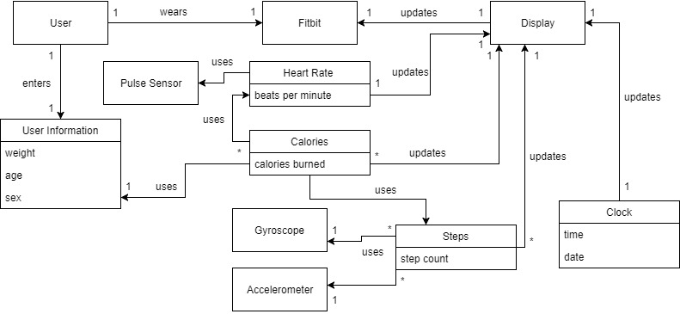

System Sequence Diagrams:

Monitoring Heart Rate -

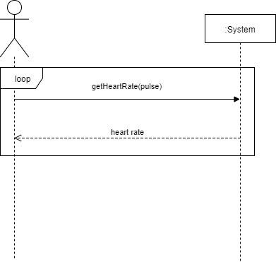

Monitor Calories Burned

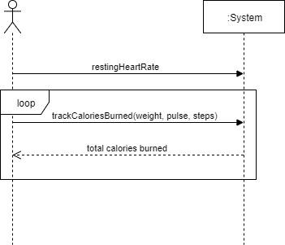

Display Clock

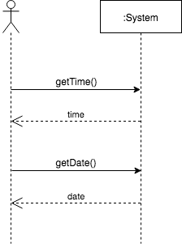

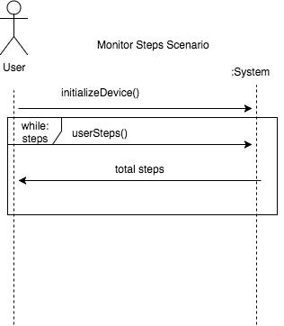

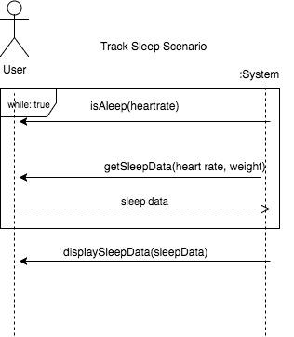

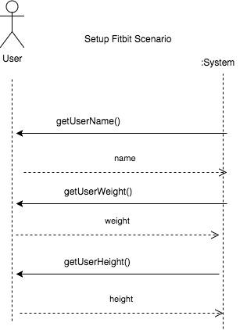

**Sequence Diagrams**

User Creation SD

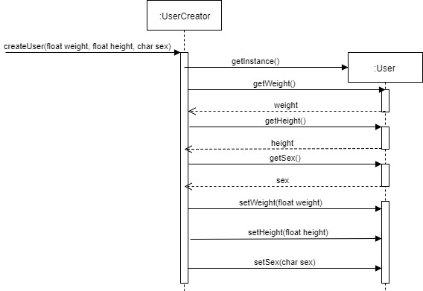

Monitor Heart Rate SD

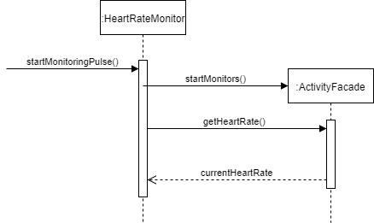

Monitor Steps SD

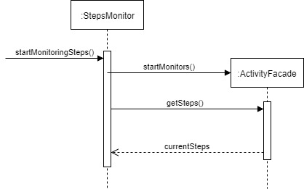

Monitor Calories Burned SD

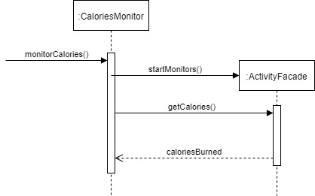

**Class Diagram:**

